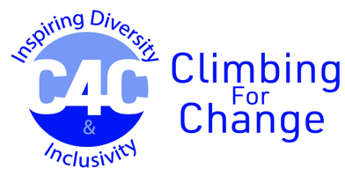 | 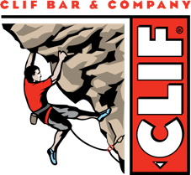

CLIF Bar Leadership Grant for AMGA Mountain Guide Programs

This document pertains to applicants interested in applying for an AMGA Mountain Guide Program. These include
- Rock Guide Course (RGC)
- Advanced Rock Guide Course & Aspirant Exam (ARGC/AE)
- Rock Guide Exam (RGE)
- Multipitch Instructor Course/Exam (MPI C/E)
- Alpine Skills Course (ASC)
- Alpine Guide Course (AGC)
- Advanced Alpine Guide Course & Aspirant Exam (AAGC/AE)
- Alpine Guide Exam (AGE)
- Ice Instructor Course (IIC)
- Ice Instructor Exam (IIE)
- Ski Guide Course (SGC)
- Advanced Ski Guide Course & Aspirant Exam (ASGC/AE)
- Ski Guide Exam (SGE)

Please upload your program acceptance letter in the Additional Supporting Documents section of the application.

